DNA, RNA, protein synthesis PPT notes

**NUCLEIC ACIDS (What are they?):**

1.

2.

3.

4.

5.

**What does** **DNA stand for**?

**DNA Nucleotides**

**What are the** **three parts of a DNA nucleotide**?

A.

B.

C.

**What are the 4 nitrogenous bases of DNA:**

1.

2.

3.

4.

**Rules for Base Pairing in DNA:**

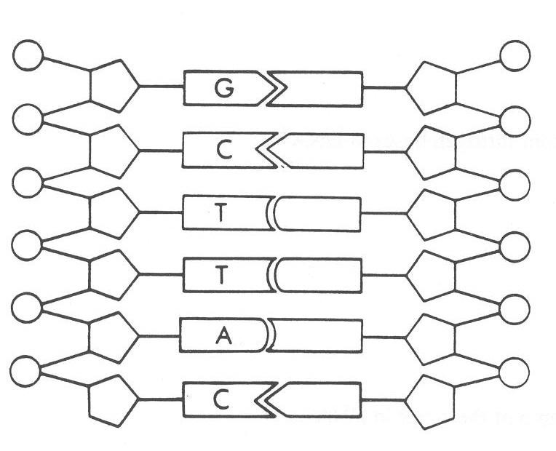

Label and pair the bases in this DNA molecule

**How many strands are in a DNA molecule?**   **.**

**What is the function of DNA?**

**What does RNA stand for?**

**How many strands are in an RNA molecule?**  .

**RNA Nucleotides**

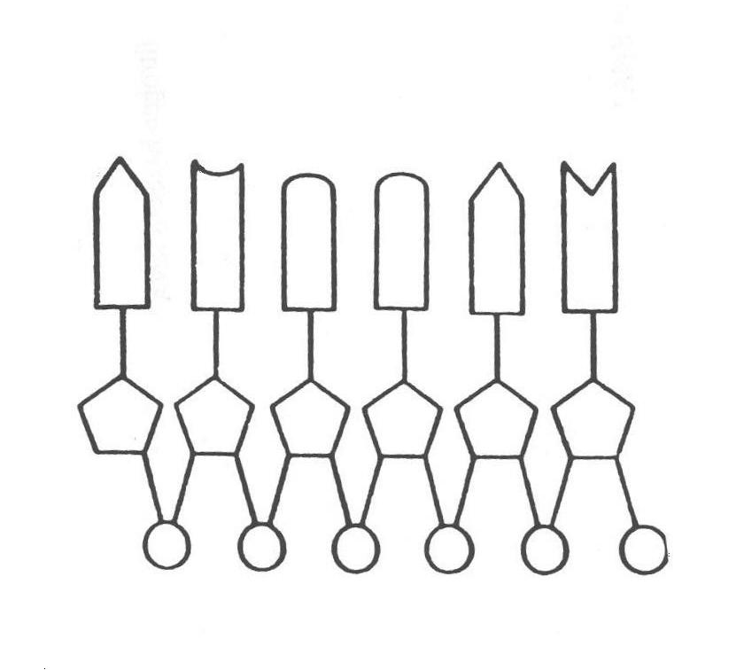

Label the RNA molecule

A.

B.

C.

**What are the 4 nitrogenous bases of RNA:**

1.

2.

3.

4.

**Rules for Base Pairing with RNA:**

**.**

**What are the functions of RNA?**

**What are the types of RNA?** A).

B. _________________________________________ C)

**COMPARING DNA & RNA**

|  |  |  |  |  |  |  |
| --- | --- | --- | --- | --- | --- | --- |
|  | DNA | RNA |  |  | DNA | RNA |
| Sugar is deoxyribose |  |  |  | Located in nucleus |  |  |
| Sugar is ribose |  |  |  | Located in cytoplasm |  |  |
| Adenine base is present |  |  |  | Stores genetic information |  |  |
| Cytosine base is present |  |  |  | Functions in protein synthesis |  |  |
| Guanine base is present |  |  |  | Composed of nucleotides |  |  |
| Thymine base is present |  |  |  | Template for synthesis of proteins |  |  |
| Uracil base is present |  |  |  | Transcribes the Template |  |  |
| Shape is double helix |  |  |  | More than one type |  |  |
| Shape is single stranded |  |  |  |  |  |  |

##### THE THREE TYPES OF RNA AND THEIR FUNCTIONS

|  |  |  |
| --- | --- | --- |
|  | ribosomal RNA |  |
| mRNA |  |  |
|  |  | help make proteins, carries an amino acid to ribosome |
| **mRNA** | http://virulentwordofmouse.files.wordpress.com/2011/07/barcode-scanner.jpg | tRNA  towing  Amino acid |

##### TWO PARTS OF PROTEIN SYNTHESIS

TRANSCRIPTION

TRANSLATION

###### STEPS IN PROTEIN SYNTHESIS

|  |  |
| --- | --- |
| TRANSCRIPTION | **TRANSLATION** |
| **Step 1:** | **Step 5:** |
| **Step 2**: mRNA is made from the DNA template   * mRNA matches with free DNA nitrogen bases in a complimentary fashion * BASE PAIR RULE   (DNA) A – U (RNA)  (DNA) T – A (RNA)  (DNA) G – C (RNA)  (DNA) C – G (RNA) | **Step 6**: tRNA helps mRNA and rRNA in making the protein.  tRNA   * is clover-leaf shaped. * Each one carries a specific amino acid. * has a three letter code known as an anticodon that complements the mRNA codon (tells it which amino acid to bring) |
| **Step 3:** | **Step 7:**   * As ribosome moves down the mRNA, the tRNA brings in amino acids which are joined together by peptide bonds. * The amino acids form a polypeptide chain that becomes a protein. |
| **Step 4:** | **Step 8:** |

Vocabulary

|  |  |  |  |  |
| --- | --- | --- | --- | --- |
| ___ | 1. | Codon | a. | the complement to the codons contained within mRNA |
| ___ | 2. | Anticodon | b. | the building blocks of proteins |
|  | 3. | Stop codon | c. | The set of 64 amino acids which mRNA codes for |
| ___ | 4. | Amino acid | d. | a grouping of three nitrogen bases in mRNA that carry the code for an amino acid. |
| ___ | 5. | Genetic Code | e. | marks the end of a gene (the genetic code for a protein) and protein synthesis ends. |

